Title: How Much Should We Rely on IT Companies?

Response Post:

Hi everyone,

I read this post about the impact of IT companies on modern business, and I’d like to share my thoughts on how their role has evolved — and whether we might be leaning on them too much.

Information Technology (IT) companies are no longer just support arms for businesses — they’ve become the backbone of the global economy, the pioneers of innovation, and, to some extent, the gatekeepers of our digital lives. From streamlining operations to revolutionizing customer experiences, IT companies are shaping everything around us. But in doing so, are they solving more problems — or creating new ones?

The Rise of IT: From Back Office to Boardroom
In the early 2000s, IT departments mainly handled internal tasks like hardware, networks, and maintenance. Today, IT companies deliver full-scale digital solutions: AI, cybersecurity, cloud infrastructure, blockchain systems — the list keeps growing. Top firms like TCS, Infosys, Accenture, IBM, and Microsoft aren’t just helping businesses scale — they’re influencing how we live and work.
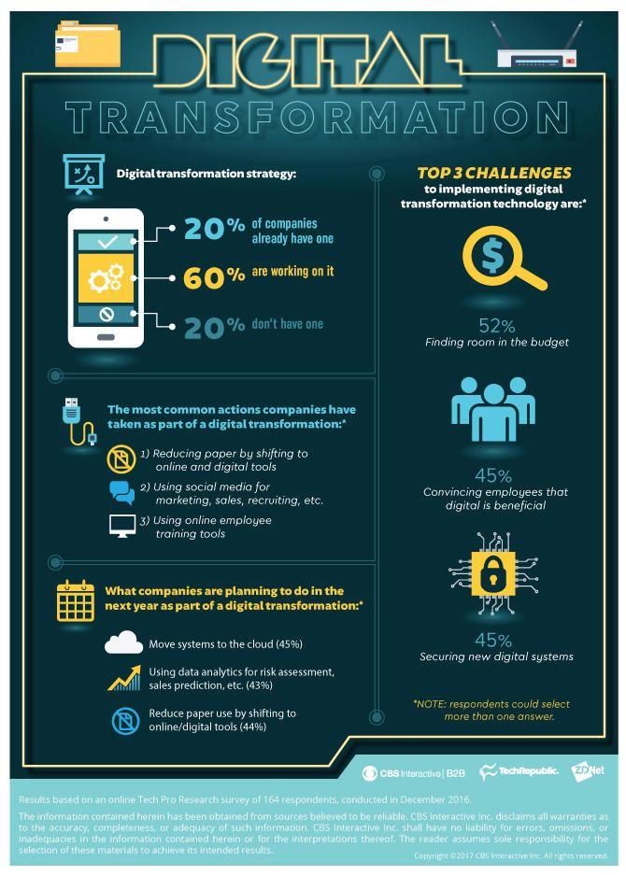
Key Drivers:
Digital Transformation: Every business is now a digital business. IT companies help industries — from healthcare to education — shift to cloud-based, data-driven systems.

Cloud Computing: Platforms like AWS and Azure allow businesses to expand without heavy infrastructure costs.

Artificial Intelligence & Automation: AI is changing how we work, but it also raises questions about job loss and ethical use.

Cybersecurity: Digital growth means more digital threats. IT firms now lead the fight against cybercrime with advanced solutions.

The Flip Side: Dependence and Risks
While IT companies drive progress, they also create concerns:

Automation displacing jobs

Tech giants becoming too powerful

Privacy risks and data misuse

Over-reliance on algorithms for decisions

Are we outsourcing not just services, but our responsibility too?

India’s Role:
India has become an IT powerhouse with companies like TCS, Infosys, Wipro, and HCL leading the global digital shift. The Digital India push and the SaaS startup boom are keeping this growth strong.
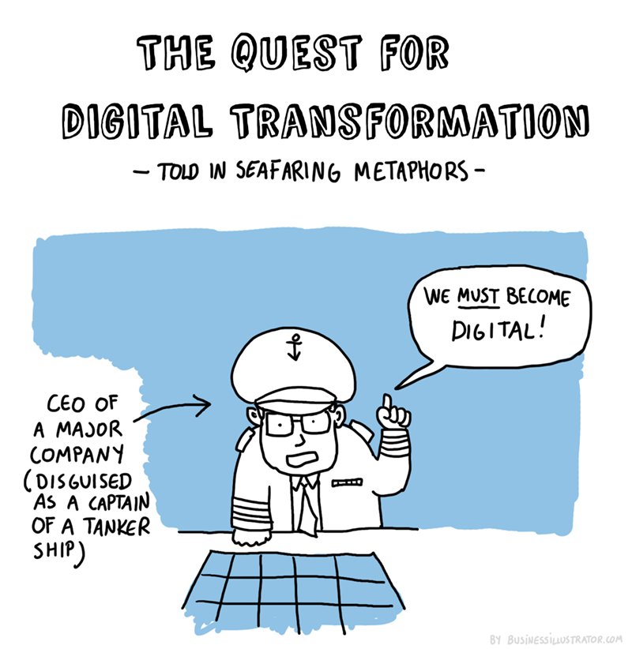
Looking Ahead:
The future should focus on collaboration over competition. IT companies will need to partner with governments and educators to solve big global challenges, like climate change and ethical AI. Startups will disrupt, but big players will remain essential for their scale and reach.

Conclusion:
IT companies are the architects of our digital age — but with great power comes great responsibility. They must innovate responsibly, respect privacy, and help build digital literacy for everyone.

So, what do you think? Are we shaping technology, or is it shaping us?
Let’s discuss!

Tags: #IT #DigitalTransformation #AI #CloudComputing #Cybersecurity

